ASSIGNMENT-1

1.
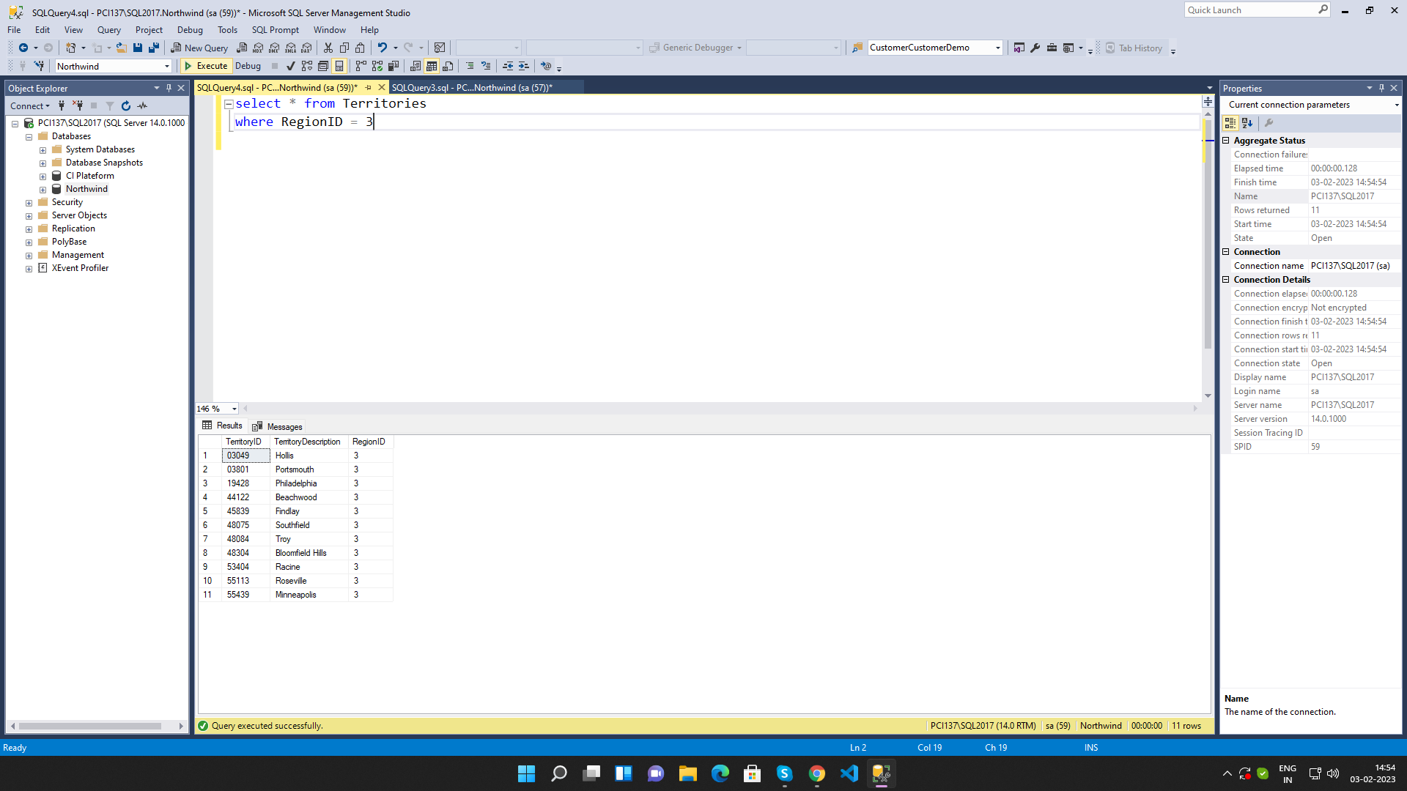
2.
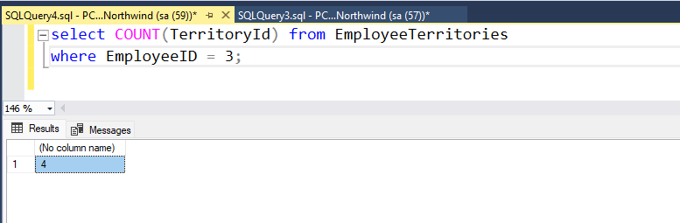
3.
